Welcome to Davao Medical School Foundation. Follow these set of instructions to create an account for Microsoft Team and learn how to login to our Webmail Portal and Student Portal.

Let's get started with setting up a Microsoft Team account that will allow you to join the classes.

Step 1:
Visit Office 365 Education (microsoft.com)
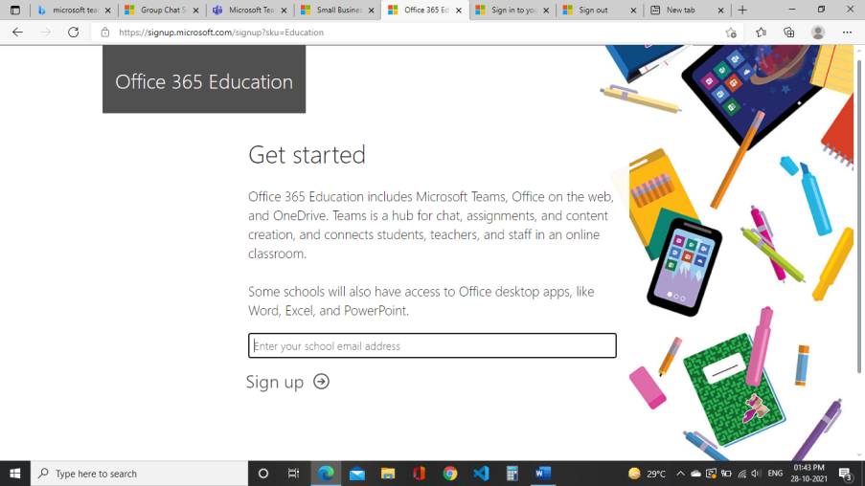

Step 2:
Sign Up with the email credential assigned to you.
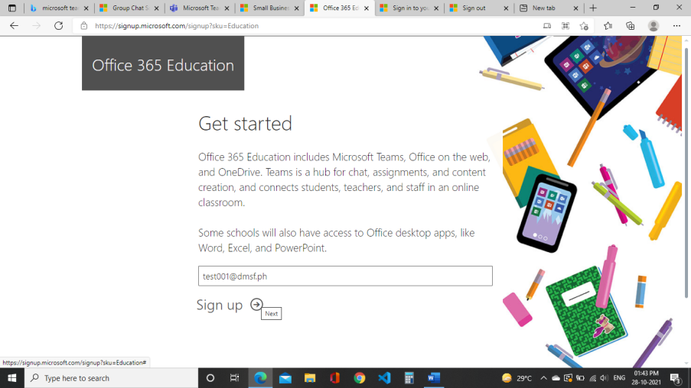

Step 3:
Select I’m a student
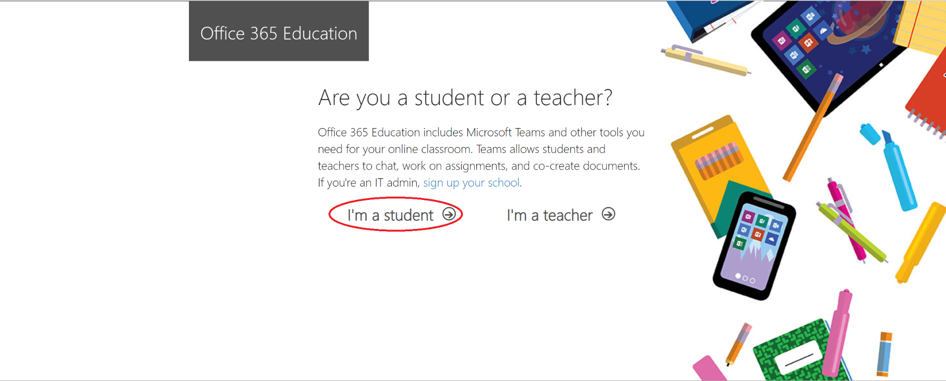

Step 4:
Fill in your details
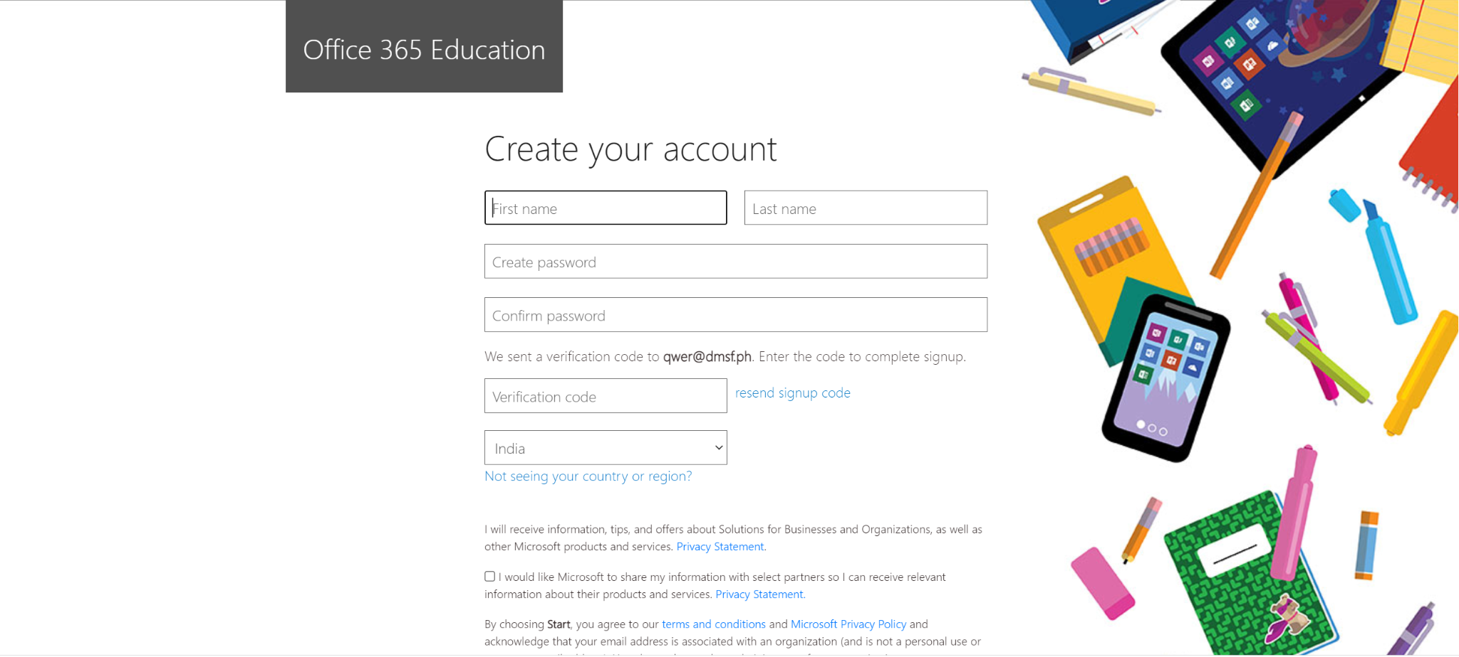

Step 5:
You will be asked for a Verification Code.

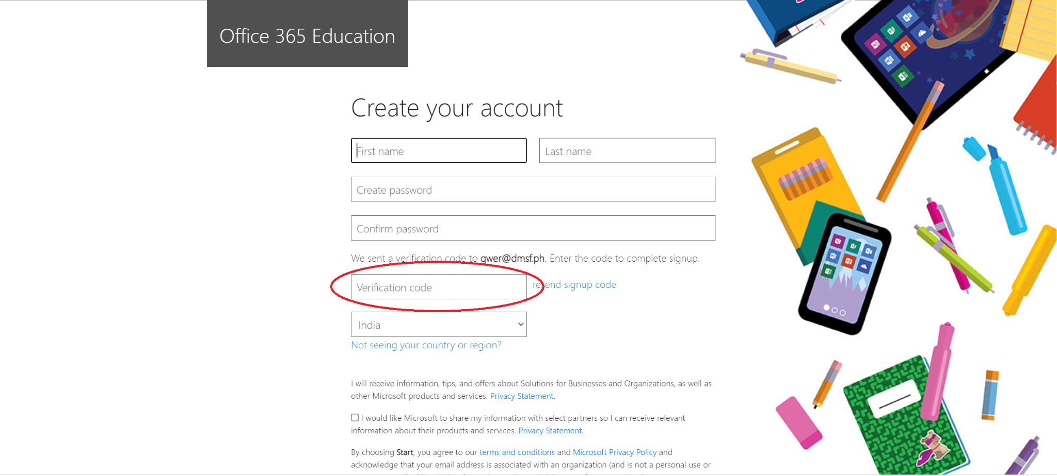

Step 6:
To access your verification code, you will need to login to your Webmail Portal. To log in to your Webmail Portal, visit https://www.dmsf.ph:2096/ in a new tab.

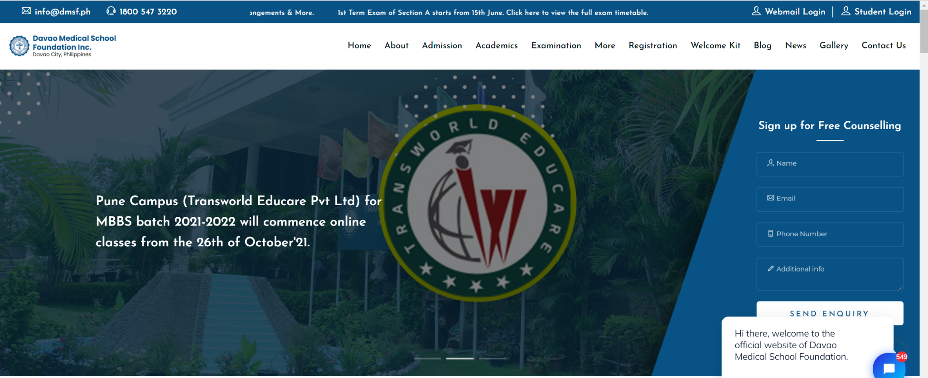

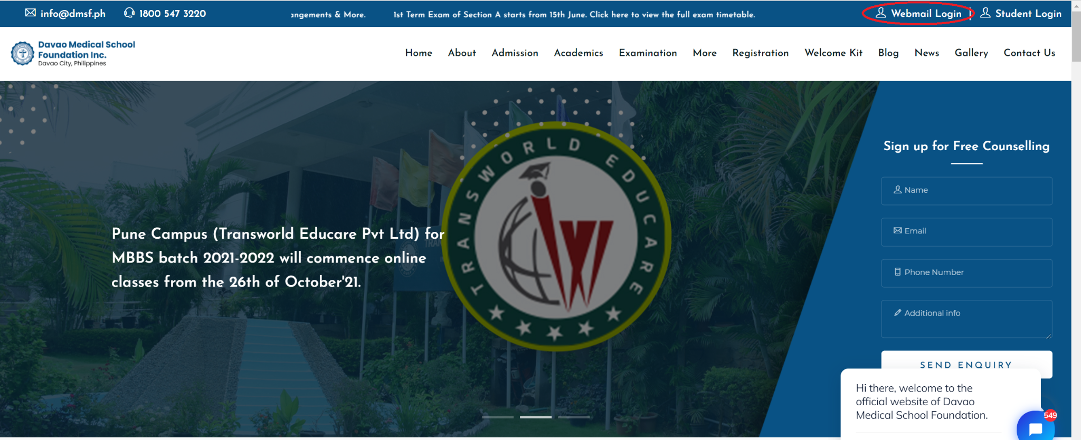

Step 7:
Use your webmail credentials sent to you over mail to log in.

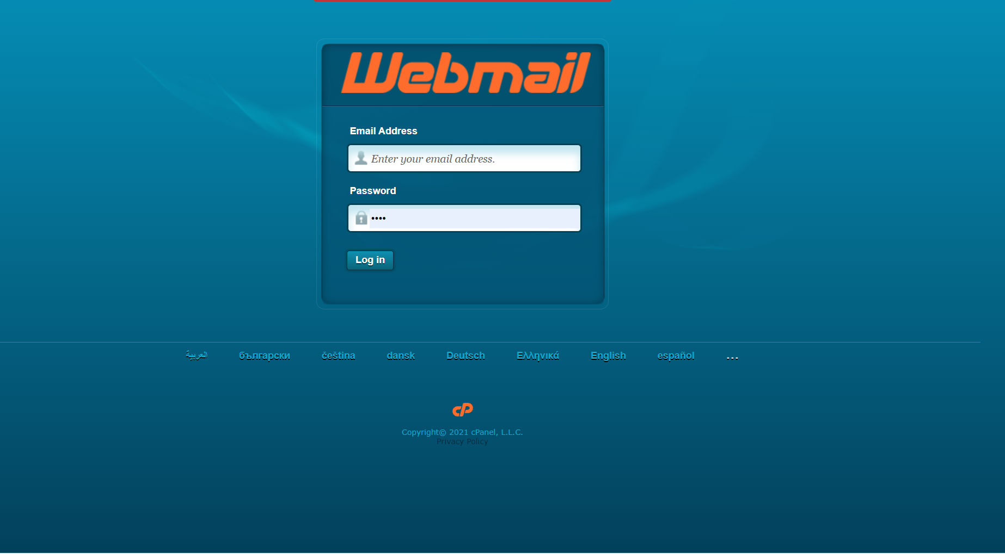

Step 8:
Select the checkbox and click open.

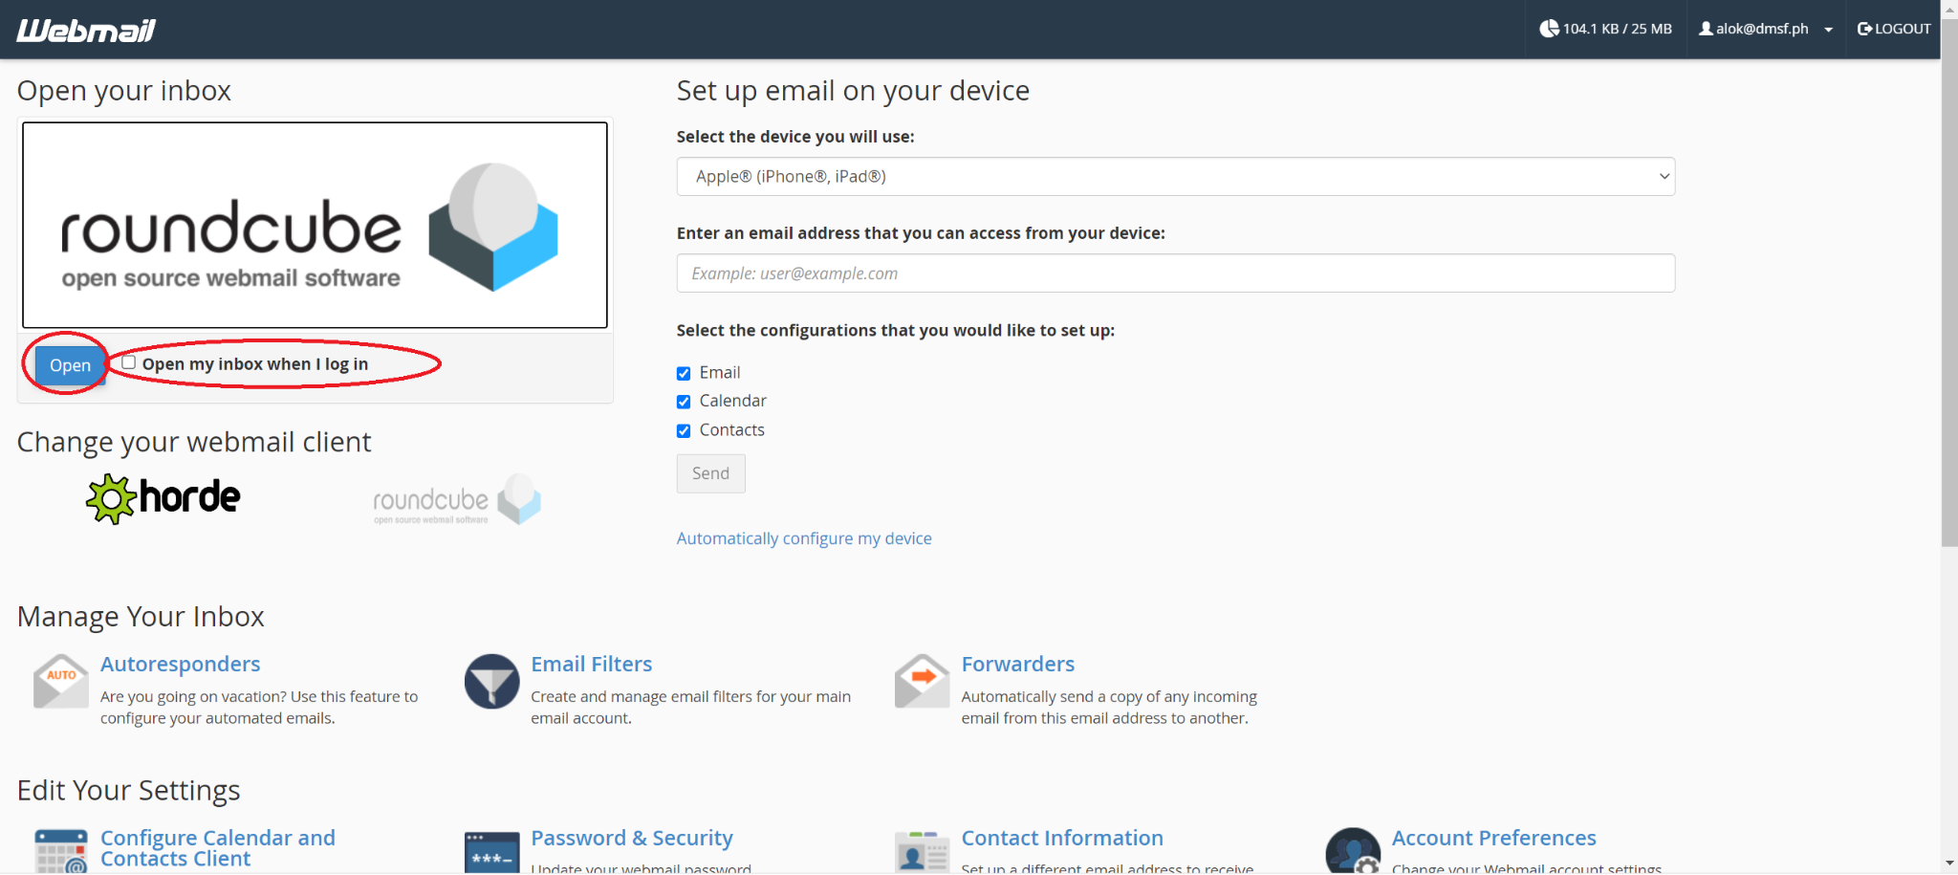

Step 9:
Note verification code sent by Microsoft.

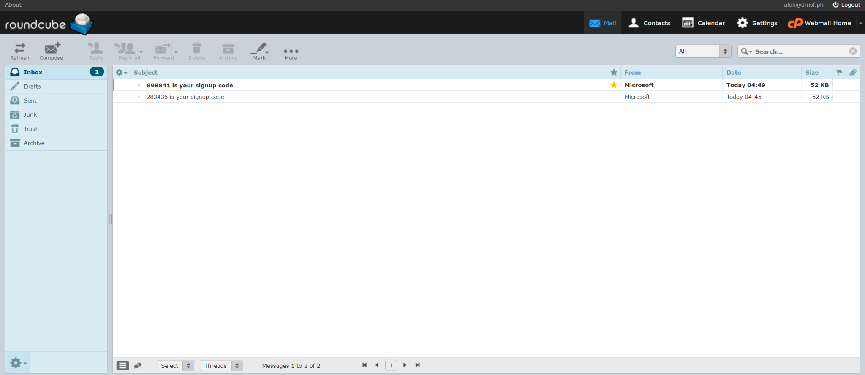

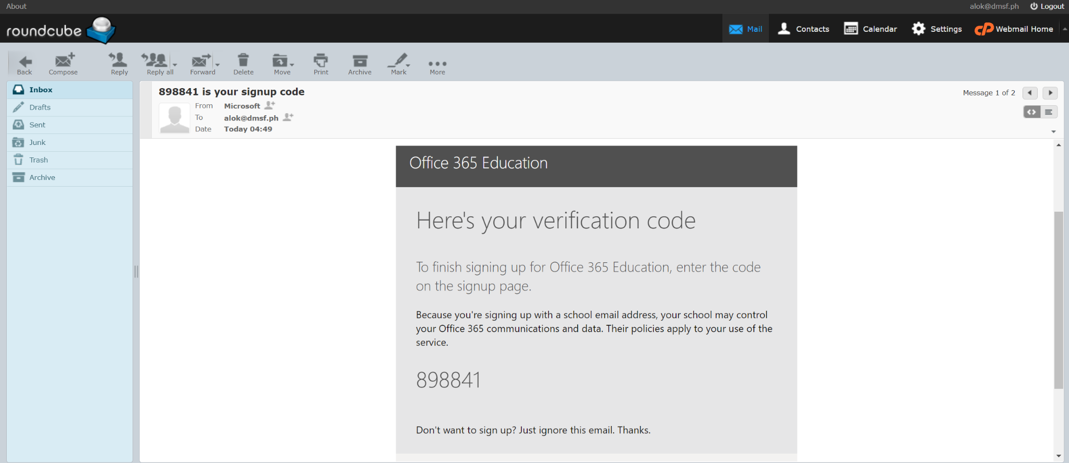

Step 10:
Enter Verification Code and Click Start

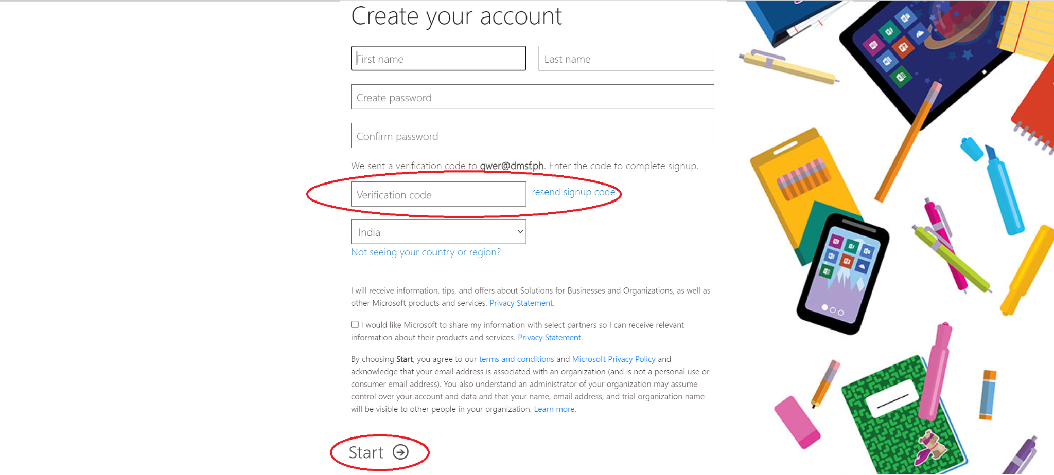

Step 11:
Click Next
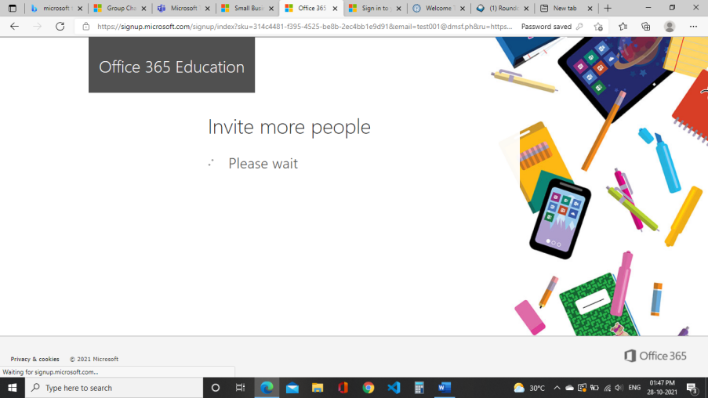

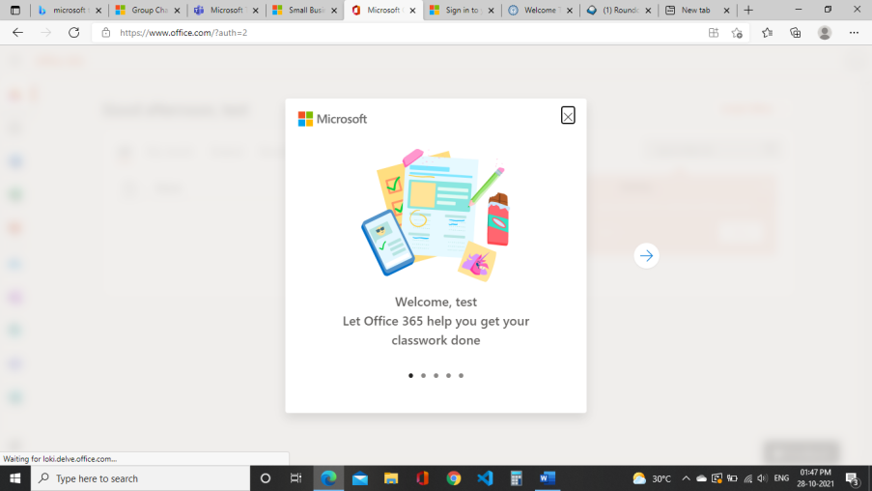

Step 12:
Select Microsoft Teams from the left hand side panel.

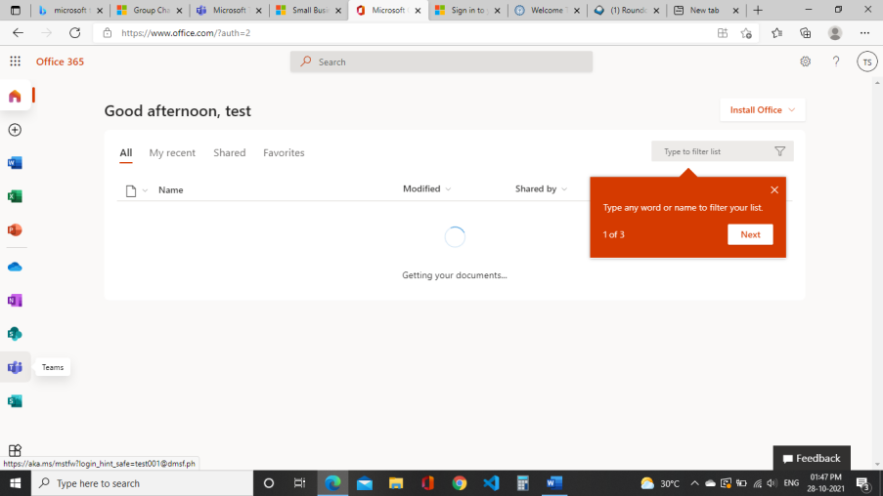

Step 13:
Select Skip For Now and click Next
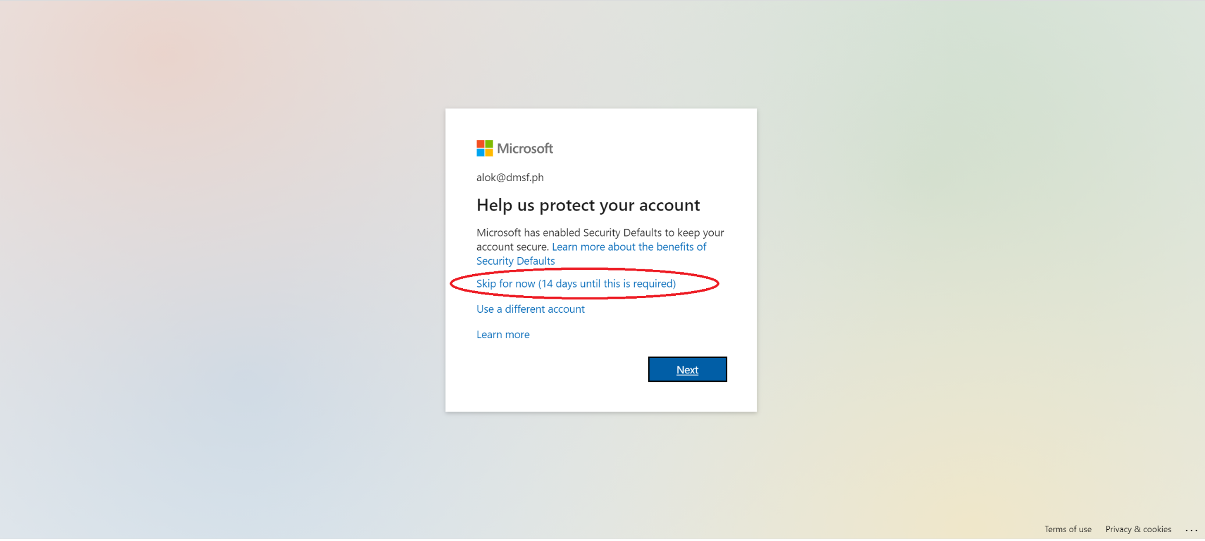

Step 14:
Your Microsoft Team account has been successfully created.

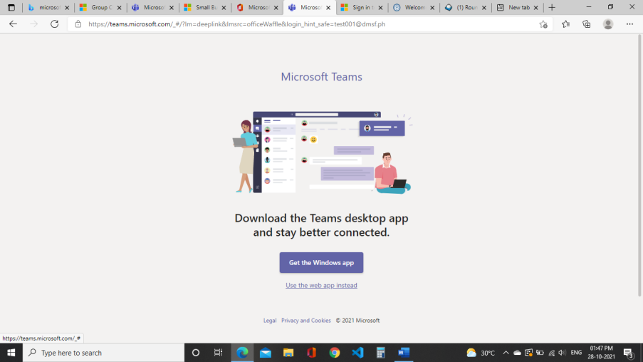

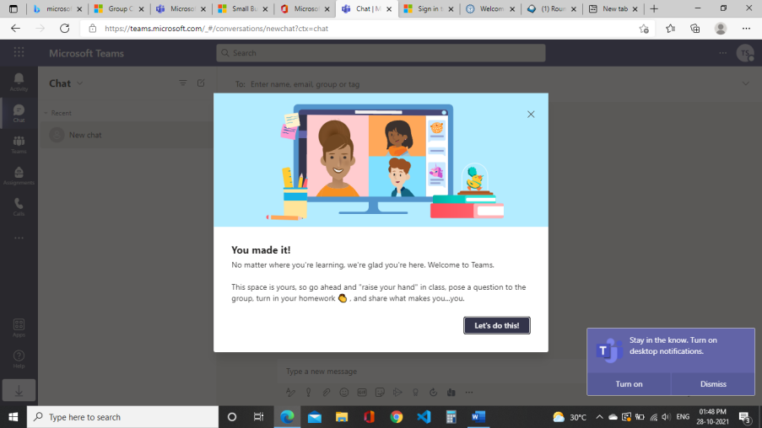

Step 15:
To join the classes, our admin will share a team code with you. Enter your team code.

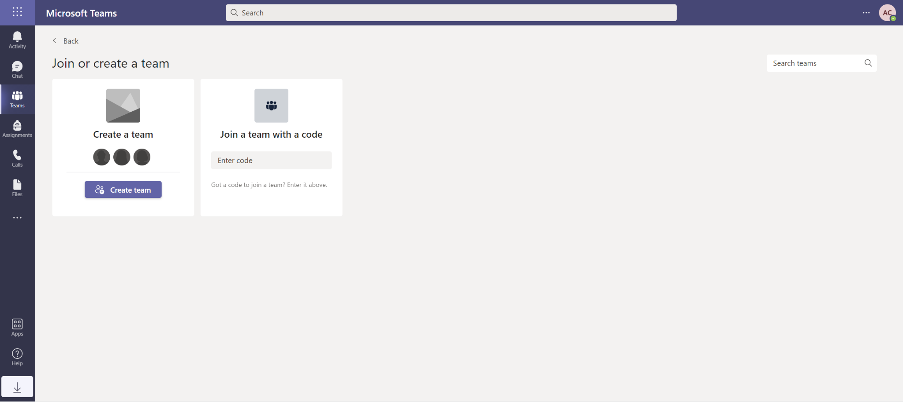

Step 16:
You have been added to the team.

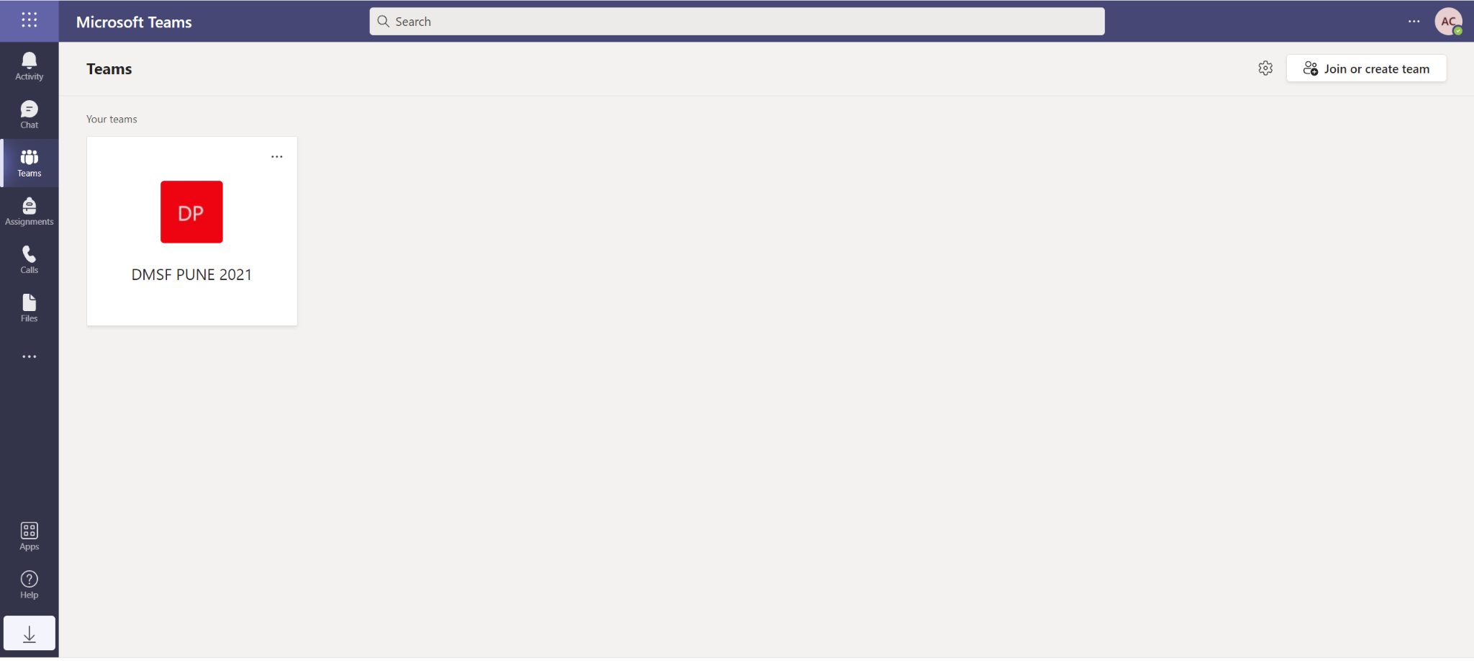

Once you set up your account, you can directly login to https://teams.microsoft.com/ with your credentials.
Student Portal Login

To check your daily schedule, notice and news update, visit https://dmsf.ph/student-portal/student/login

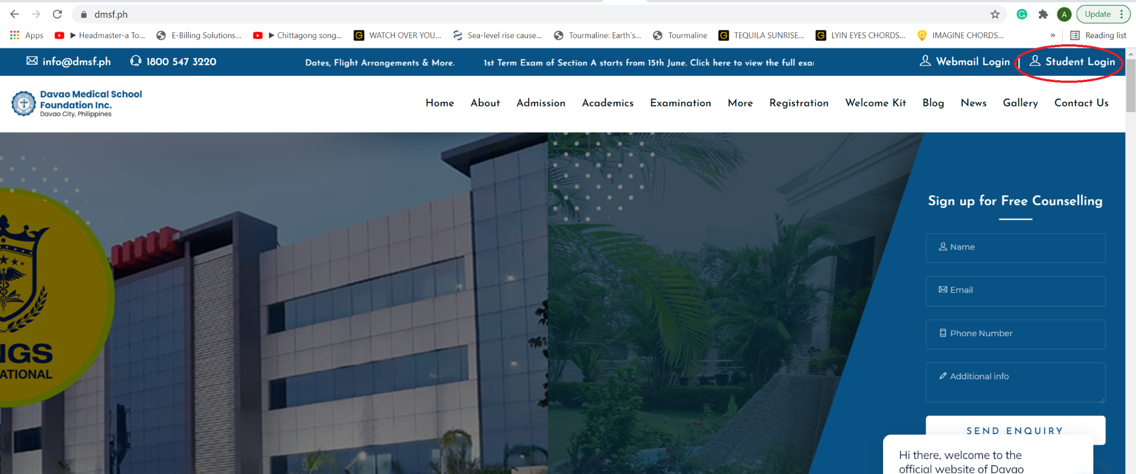

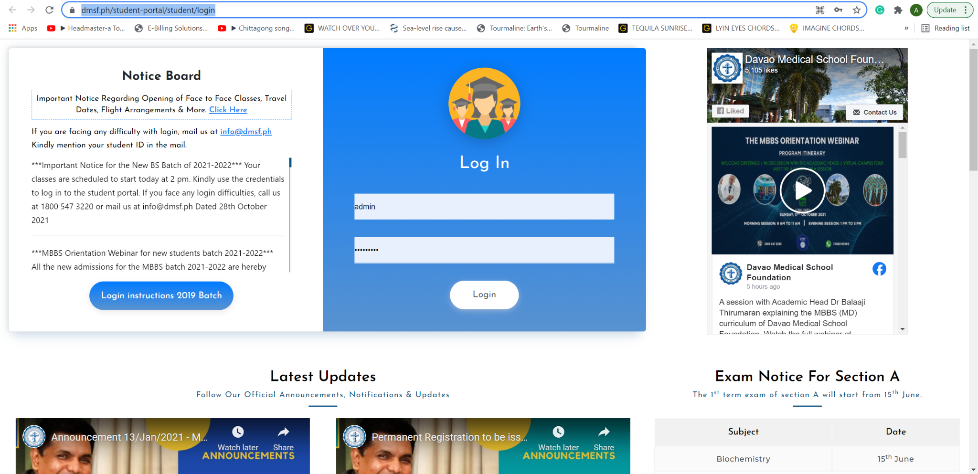

Use your Student Portal Credentials as shared to log in.

You have successfully logged in to your student portal.
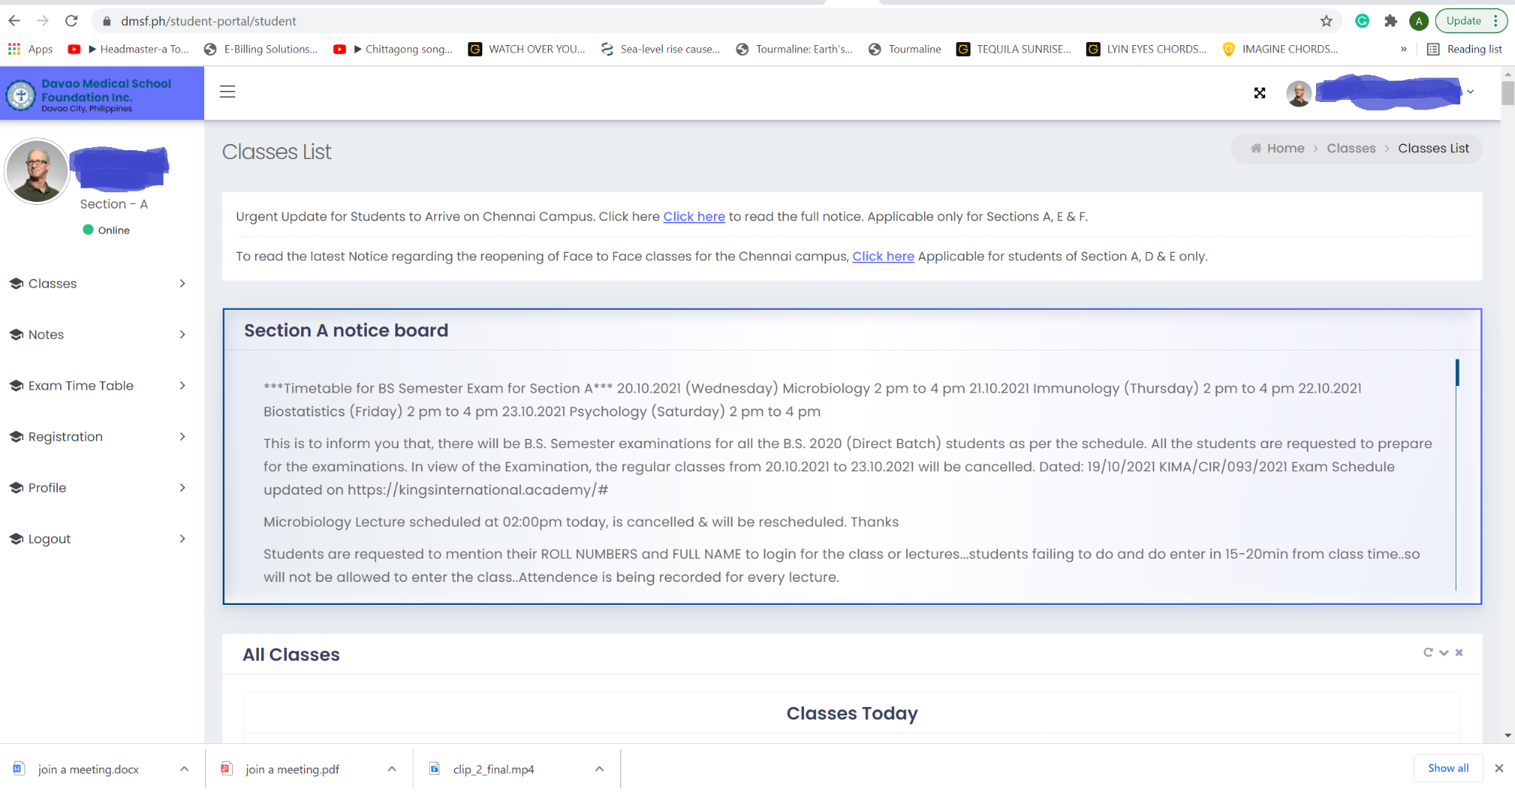

Visit official website https://www.dmsf.ph
For any login related issues, mail us at info@dmsf.ph or call us on our toll free number 1800 547 3220

